Salmonella Control Scheme Q@A’s
Listing for my egg Farm
You do not need to list if you are already registered as a layer farm under the RMP
To register the clip-on, you would need to fill out an AP50 form for the minor amendment, and submit it along with the RMP clip-on, site plan and fee, to MPI, to have the minor amendment registered.
The clip-on should be checked (and overall compliance to the ECS) within 4 months from the implementation of the ECS. For some it will be an additional verification visit, so not necessarily your next scheduled verification. The verification will also cover parts of the egg RMP template as well, as parts of the ECS are already covered in the template.
If you are currently registered with MPI with a template egg RMP, you can continue to use your current verifier i.e., MPI Verification Services. You will not need to be provided with a new verifier letter. You can notify your usual verifier once you have registered the egg RMP clip-on.
Regards New Zealand Food Safety
Ministry for Primary Industries

RMP Clip On form
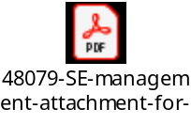
AP50 form
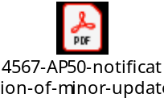
Site for guidance info for specific types of Poultry
Search | NZ Government (mpi.govt.nz)

Results of testing
Only positive Salmonella Enteritidis results need to be reported to MPI
Other test results must be kept in your records to show you are testing as required by the Salmonella scheme.
Important dates

Registration
via Listing or via the clip on RMP (for layers farms with RMP) is 6th November

RMP and rear birds
The advice we’ve received for farms registered with an egg template RMP who also do rearing, is that they will need to both:
- register a minor amendment with the egg template clip-on, for the RMP; and
- list the rearing under the ECS and comply with the requirements of the ECS for the rearing part.
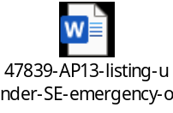

Testing
Testing needs to start within a month of order date being gazetted
IE. Gazetted on 6th October 2021
IE. Testing starting from 6th November 2021

Version 1. 3/11/21

